
Ecosystems
ICT Task Week 1

Learning Intention:

Success Criteria:

Task 1

- Use this link to access Science By Doing:
https://www.sciencebydoing.edu.au/
- I am a student.
- Email: studentlogin101@gmail.com
- Password: studentpassword101
- Student digital
- Click 1.1

Part A
Complete the table by ticking which type of ecosystem the following organism lives in by reading the information on Science By Doing task 1.1.

Type of organism | Type of ecosystem
Type of organism | Desert | Rainforest | Wetlands
Austrobaileya
Bilby
Bulrush
Azolla
Green and golden bell frog
Mulga bush
Musky rat-kangaroo
Silk cotton tree
Southern cassowary
Spinifex
Water-holding frog
Australian white ibis

Questions

- Pick an animal and describe a feature it has that allows it the live in the wetlands.

- Pick a plant and describe a feature that allows it to live in the rainforest.

- What about the desert environment limits what sorts of plants and animal live there?
Hint: find an animal or plant that doesn’t live in the desert and think about the reasons why it doesn’t

Part B
Complete the following table by researching on the internet. Please write the definition IN YOUR OWN WORDS

Term | Definition | Examples
Herbivore
Carnivore
Omnivore
Consumer
Second order consumer
Producer
Parasite

Task 2

- Construct a Venn diagram, with circles labelled ‘Living factors’ and ‘Non-living factors’.

- Place each of the following words in the correct circle.

Aluminium colour glass pipe snail bread cotton fabric grapes pork chop tree clock fingernail grass salad water clouds fish pen sand whale wooden ruler

- Now investigate and determine the living and non-living factors influencing two different sections or areas of our school.

- List the living and non-living factors that are found in each of the following ecosystems:

- Great Barrier Reef

- Simpson Desert

- Daintree rain forest

- Murray River red gum forest

- To create an acrostic definition, a word (for example TEACHER) is written vertically down the page. This is used to generate a ‘definition’ of the word. In the example, the first word of the definition begins with the first letter of TEACHER, the second word begins with the second letter, and so on.

Talented
Educated
Attentive
Caring
Helper
Everyone
Respects

Create an acrostic the defines ECOSYSTEM

E
C
O
S
Y
S
T
E
M

Task 3

- Use this link to access Science By Doing:
https://www.sciencebydoing.edu.au/
- I am a student.
- Email: studentlogin101@gmail.com
- Password: studentpassword101
- Student digital
- Click 2.1

- State what types of organisms are in each montage as either Producer, Consumer, or Decomposer.

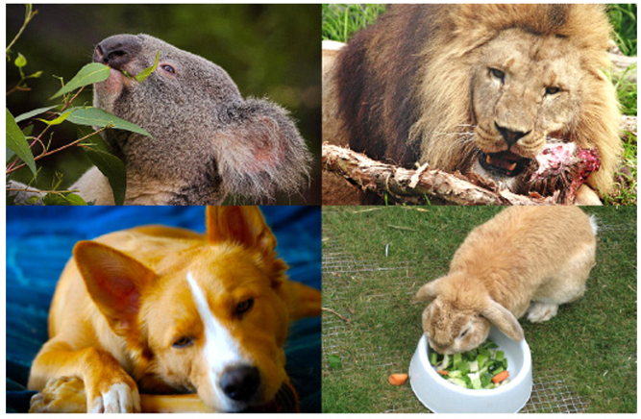

Montage 1

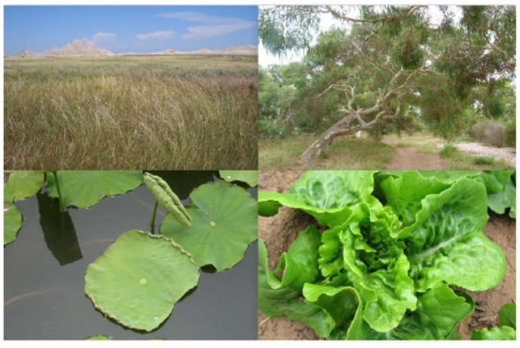

Montage 2

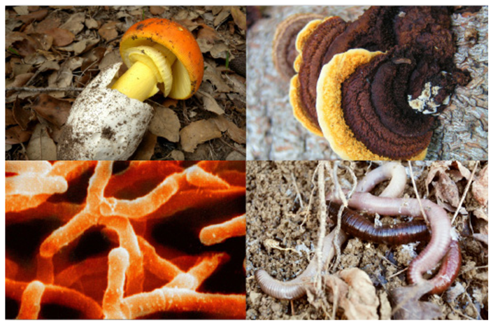

Montage 3

- How do each montage of organisms get their energy?

Producer:

Consumer:

Decomposer:

